**BURTON LATIMER MEDICAL CENTRE**

Higham Road

Burton Latimer

Northants

NN15 5PU

Tel: 01536 723566

Website: <https://www.burtonlatimermedicalcentre.co.uk>

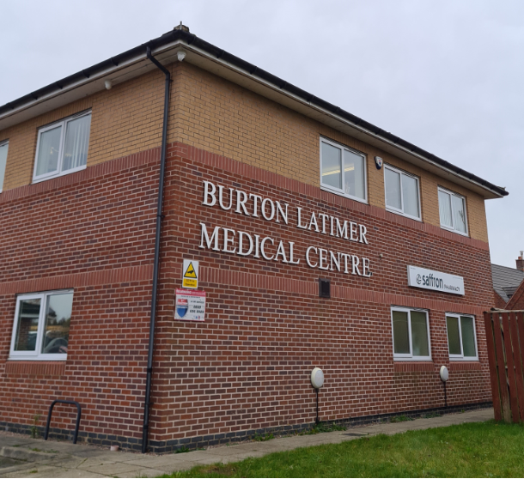

**Welcome to Burton Latimer Medical Centre**

Our practice team are committed to providing high quality care for our patients, including suitable access for disabled patients. Our practice is highly patient focused, and we have a multidisciplinary approach to patient’s health care. We aim to deliver the best for our patients by combining the skills of the practice team with other health and social care workers in the community.

**Our mission at Burton Latimer Medical Centre is to provide the highest standard of care to all of our patients in a safe, well-led and caring environment.**



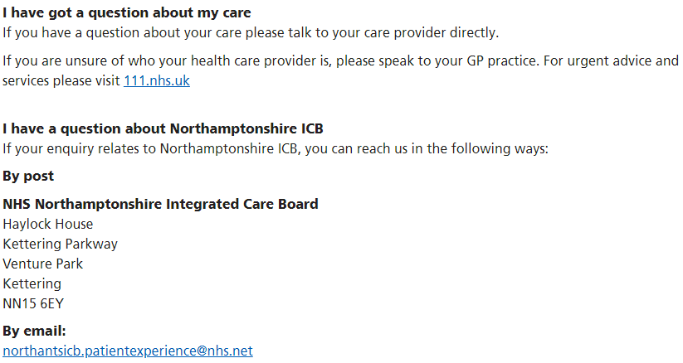

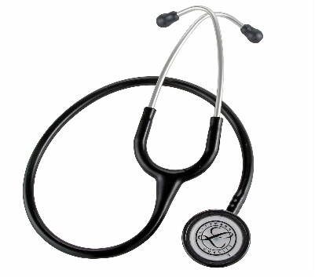

**The Burton Latimer Medical Centre Team**

**The Doctors**

**Dr Charles N Spencer** (Male) MBBS (1997 London)

**Dr Rowan J Child** (Female) MBBS BSc DFFP (1997 London)

**Dr Apoorvaa Raja** (Female) MBBS BSc MRCGP DRCOG (1998 London)

**Dr Toby Rose** (Male) MRCGP MBChB (2002 Sheffield)

**Dr John Delaney** (Male) MBBS DRCOG DFFP MRCGP 1997 (London)

**Dr Martin McGrath** (Male) FFMLM FRCGP MBChB DAvMed DipIMC RCSEd MA



**The Nursing Team**

**Advanced Nurse Practitioners**

**Georgie Butlin, Ruth Crowhurst, Julie Robinson, Kylie Trinder and lead by Nurse Manager Steph Cowper.**

Our team of advanced nurse practitioners see urgent on the day illness. They are available by appointment for the treatment of minor illnesses where they work closely with the GP’s and can prescribe where appropriate.

**Practice Nurses**

**Mary Lewis –** RGN Dip Prof Studies in Nursing, BA healthcare, Cert, Diabetes

**Melissa Andrews** – PG Cert Practice Nursing, BSc Adult Nursing RGN

**Mary and Melissa** can be seen by appointment for dressings, injections, removal of stitches, dopplers and travel or child immunisations, as well as general health checks for men and women, cervical screening, and family planning services.

**Mary** can be seenby appointmentduring specialist clinics for diabetes.

**Nursing Associate**

**Leah Hackney** can be seen by appointment for NHS health checks, immunisations including Flu, Covid and B12, Long Term Condition reviews, ECG’s, blood pressure monitoring and dressings.

**Health Care Assistant**

**Sally Gazeley** supports the nursing team by performing various procedures such as blood pressure monitoring, dressings, health checks and Long Term Condition reviews. She can also take blood and give B12 and Flu vaccinations.

**Blood Tests (Phlebotomist)**

**Julie Murdin** is our phlebotomist and can be seen by appointment for blood tests every weekday until 12pm. She is also available for blood pressure readings.

**Care Co-Ordinator**

**Jinal Panchal** can be seen by appointment for blood tests, Long Term Condition reviews, Cancer Care reviews, B12 and Flu vaccinations.

**Social Prescriber Link Worker**

**Our Social Prescriber** provides support to patients with a wide range of social, emotional, and personal needs where non-medical issues are affecting their health and Cancer care reviews.

**Pharmacy Technician**

**Amy Stout** undertakes clinical medication reviews and proactively support patients with long-term complex conditions.

**Virtual Pharmacy**

Our virtual pharmacy undertakes medication reviews, medication queries, HRT medication reviews, blood pressure reviews and BP follow ups.

**Musculoskeletal Physiotherapy**

**Chris Heywood** provides first contact physio for our patients regarding muscular skeletal issues including back, shoulder and, foot problems.

**Digital and Transformation Lead**

**Darren Whiting** is the digital and transformation lead across Burton Latimer Medical Centre.

**Chaperones**

All patients are entitled to have a chaperone present for any consultation. Please speak to the doctor or nurse at the beginning of your consultation.

**Practice Staff**

*Practice Business Manager* – **Helen Beesley**

Our Practice Business Manager is responsible for the management of the practice.

*Deputy Practice Manager* **– Jane Evans**

*Operations Manager* – **Sarah Bond**

*Systems Manager* **– Jenny Babb**

*Administration Staff* – **Joanne Burns, Bridget Lacey, Julie Crowther, Allison Lockwood, Ann Maurizi, Tyr-John Baverstock, Katie Walters and Esther Govada**

*Receptionists* – **Diane Langley, Shelley Labrum, James Tildesley, Anne-Marie Deane, Deborah Sullivan, Louise Beale and Heather Smith**

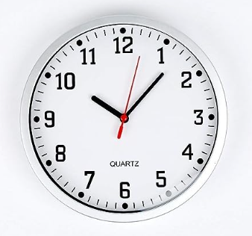

**Surgery Opening Hours**

**Monday**: 08:00 – 18:30 (doors close at 18:00)

**Tuesday**: 08:00 – 18:30 (doors close at 18:00)

**Wednesday**: 08:00 – 18:30 (doors close at 18:00, see below for PLT opening hours)

**Thursday**: 08:00 – 18:30 (doors close at 18:00)

**Friday**: 08:00 – 18:30 (doors close at 18:00)

**Saturday**: CLOSED

**Sunday**: CLOSED

(*Closed Bank Holiday Mondays)*

*Protected Learning Time:* This means the practice will be closed from 12:30pm on the

published Wednesday afternoons for training purposes according to the Northants ICB

PLT Dates 2024/25:

8th May 2024, 12th June 2024, 10th July 2024, 21st August 2024, 11th September2024, 9th October 2024, 13th November 2024, 4th December 2024, 15th January 2025, 12th February 2025, 12th March 2025.

**Appointments**

To make an appointment, please telephone **01536 723566** or visit the reception desk during opening hours. We operate a computerized appointment system; pre-bookable GP appointments are available up to 2 weeks in advance. You may request the doctor of your choice, but this will be subject to availability. Telephone appointments are also available from a GP or Advanced Nurse Practitioner if you do not need to be seen face to face.

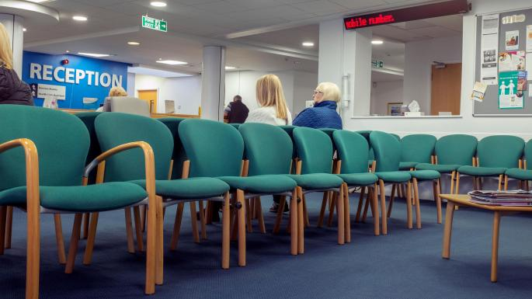

**Cancelling Appointments**

If you are unable to keep your appointment, please inform the practice as soon possible. Missed appointments are a waste of our health professional’s time and take away valuable appointments from other patients. Additionally, if you are more than 10 minutes late for your appointment you may need to rebook.

**Home Visits**

Home visits will only be made to patients who the doctors consider to be too ill to come to the surgery, are immobile or housebound. There is no automatic right to a home visit and requests should be made, if possible, before 10:30am. When scheduling a home visit please give the receptionist as much information as possible to assist the doctor when deciding the degree of urgency.

**Out of Hours Service**

NHS 111 provides an emergency out of hours service for evenings and weekends for urgent medical problems. Patients may be offered advice by telephone or be asked to visit the Out of Hours Centre at Kettering General Hospital. The nearest Walk-in centre is Corby Urgent Care, Cottingham Road, Corby, Northamptonshire, NN17 2UR Tel: 01536 202121

**Extended Access**

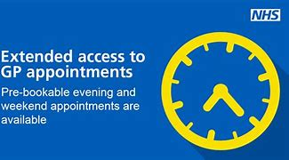 Making it easier to get an appointment at a time that suits you. Appointments are available each day through the shared service with other practices in the area. This service is based at Prospect House, Lower Street, Kettering, NN16 8DN.

**PPG – Patient Participation Group**

This is made up of patients and practice staff who meet every other month to consider ways of making a positive contribution to the services and facilities offered by the practice to patients. If you would like to find out more and maybe join, please contact Helen Beesley (Practice Business Manager) or Joanne Burns (Secretary) on **01536 723566**

**Ordering Medication**

**We do not take requests via the telephone.**

We require two working days of notice for your prescription to be ready for collection or for your prescription to be sent to your nominated pharmacy.

If you need long-term medication, your doctor will authorise you to obtain repeat prescriptions. To re-order your prescription please complete your re-order form.

**Electronic Prescriptions**

If you have selected a nominated pharmacy, once the GP has electronically signed off on the request, the prescription will be sent electronically to the pharmacy for you to collect. This is the primary way we process prescriptions at the surgery, if you would like your prescription to be sent electronically, please ask the surgery for guidance on signing up for online services and make sure you have a nominated pharmacy.

**Paper Prescriptions**

If you are not signed up to a pharmacy or your medication requires a GP to physically sign it off, you will need to collect your paper prescription from the surgery.

**Repeat Prescriptions On-line**

Patients can order their repeat prescriptions on-line, please ask reception for your website log in details. You will need a form of photo ID for us to give you this information.

**Repeat Prescriptions**

Patients can order their repeat prescriptions in the surgery by ticking the required medication on their printed repeats list or by bringing in a piece of paper with their details on including name, address, medication and then posting it through our prescriptions box or handing it to reception. You can also use the NHS app to order repeat prescriptions providing you have a nominated pharmacy.

Additional Information:

If you wish for your prescription to be posted back to you, please enclose a stamped, addressed envelope, and allow enough time for the postage and delivery of the prescription plus the two working days to process the prescription as well.

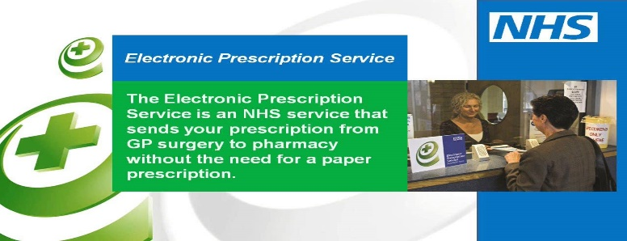

**Exemplar timelines for the processing of prescriptions:**

* Brought into surgery on Monday – prescription will be ready for collection after 1pm the following Wednesday.
* Prescriptions posted through the surgery letter box across the weekend – will be ready for collection after 1pm the following Wednesday.

**Services We Provide**

**Asthma/COPD Clinics**

Our Respiratory Nurse specialist runs these clinics, we offer regular review of treatment and instruction in inhaler use and self-help guidance.

**Cervical Screening**

Reminders for these tests are sent to female patients directly from the local screening department of NHS England. Upon receipt, please telephone or book through the self-booking link with a practice nurse.

**Diabetic Clinics**

These clinics are run by the practice nurse qualified in this field. All diabetic patients on our register are invited for annual checks. Regular review of diabetic control is actively encouraged.



**District Nurses**

District nurses provide highly skilled nursing care for patients and their families who are too frail or poorly to attend the surgery and patients who are housebound. The district nurses are a 7 day a week service from 8am – 6pm. They can be contacted on 0300 777 002. There is an evening nursing service which is contactable through the 111 Out of Hours Service.

**Family Planning**

A full range of services are offered during routine surgery appointments, please ask your doctor, nurse practitioner or practice nurse for advice. Emergency contraception is available after discussion with a nurse or can be obtained from your local pharmacy.

**Health Visitors – Child Health Clinics**

Health visitors are qualified nurses with specialist training in family health and child development. Their primary responsibility is for the promotion of good health and the prevention of ill health. They work together with other health professionals such as doctors, midwives, speech and language therapists, dieticians, and children’s social care. They run Child Health Clinics where you can have your baby weighed and discuss your baby’s progress and any problems you may have. They can be contacted at the Heath Visitor Hub on 0300 1111 022, option 4.

**NHS Health Checks**

Patients get invited via an Accurx invite to have an NHS Health Check at the surgery. the patient must be aged between 40 – 74 years old and not have any of the following pre-existing conditions: heart disease, chronic kidney disease, diabetes, hypertension, atrial fibrillation, transient ischaemic attack, inherited high cholesterol, heart failure, stroke or currently being prescribed statin for low cholesterol.

**New Patient Health Checks**

All new patients who register at the practice are welcome to have a new patient health check which is a free checkup of your overall health. These results can help the practice team understand the patient better and address any current or future health issues. Please call to make an appointment or book into an appointment via the Accurx invite.



**Talking Therapies**

A service called Talking Therapies is offered at this surgery. Your doctor can offer to refer you to a specially trained nurse who can see you at the surgery to help with a range of issues related to mental wellbeing.

**Minor Surgery**

Dr Charles Spencer, Dr Toby Rose and Dr John Delaney are qualified to perform certain surgical procedures in our specially equipped minor operations suite. Your doctor will advise you where this is appropriate.

**Physiotherapy**

This service is obtained through a referral from a doctor. Appointments are sent directly to the patient by the physiotherapy department at Kettering General Hospital.

**Private Services**

Private medical examinations can be performed by the doctors at the surgery for a fee. These include insurance, HGV, PSV, pre-employment, and sports medical examinations. Other private services include holiday cancellation and fitness to travel forms. Details of the fees are available form reception and on the practice website.

**General Practice Information**

**Access**

All consulting and treatment rooms on the ground floor are accessed via reception at the front of the building. The upstairs consulting rooms can be accessed by the lift or stairs.

**Audit Of Patient Records**

Anonymised, non-identifiable patient data is often required by the NHS. Collection of this may be carried out by persons who are not medically qualified but are bound by their contract to respect patient confidentiality as outlined by GDPR. If you object to your records being used in this way, please contact the surgery.

**Confidentiality**

The surgery uses a computerised record system for recording patient consultations, medical details, past medical history, and registration details. Everyone employed at the practice uses this system as appropriate for their role. All patient information and records are held in the strictest of confidence and all staff are bound by the rules of confidentiality under the data protection act 1998. Disclosure of information to third parties requires patients consent. The practice has a ‘Caldicott Guardian’ who oversees the security of information.



**Disabled Patients**

The building has been designed to be accessible to all patients, including toilet facilities, dedicated parking spaces and a drop off point beside the main door. A wheelchair is also available.

**Medical Certificates**

Medical certificates for the first 7 days of work absence are available from your employer, the post office, or from the internet medical certificates. After this, they will be provided by your GP at the time of consultation.

**New Patients**

To register you will need to complete a registration form which is available from reception or via the practice website. You will only be eligible to register if you live within the practice area, you can input your postcode on our website to verify this before you register.

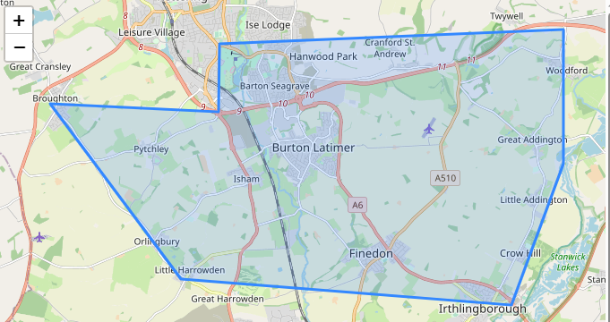

**Patient Toilets**

Toilets including disabled facilities and baby changing facilities are available on the ground floor, there is also an additional patient toilet on the first floor.

**Suggestions or Complaints**

We are happy to receive constructive comments and suggestions for improving our services for patients. However, there may be occasions when we do not meet the high standards, we set ourselves and we appreciate patients bringing these to our attention. If you are unable to obtain satisfaction from the member of staff involved in your complaint and wish to take it further, then any complaints should be addressed to the attention of the Practice manager. If you are still not satisfied with the outcome of your complaint, you are able to contact the Complaints manager, NHS England, PO Box 16738, Redditch, B97 9PT. Tel 0300 311 2233, email: [england.contactus@nhs.net](mailto:england.contactus@nhs.net).

**Test Results**

Blood and urine tests will generally take three to four working days before the results are available. X-rays, MRI and US scans can take at least seven days. The results of cervical smears can take several weeks, patients are not normally contacted with results unless they are abnormal.

**Violence or Abuse**

The practice supports the governments ‘Zero Tolerance Policy’. Violence and abuse are a growing concern. General Practitioners and their staff have a right to care for others without the fear of being attacked or abused. Violent patients will be reported to the police and removed from the practice list.