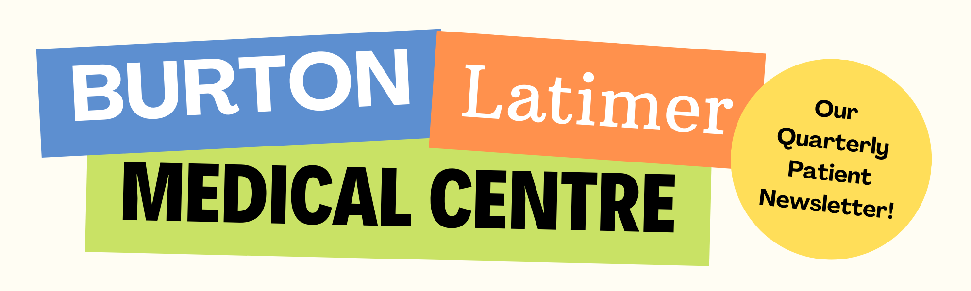**Welcome to Our Spring ’25 Newsletter!**

**Welcome back** to our patient newsletter! We are excited to announce that the Medical Centre will be releasing quarterly editions from the New Year to provide you with updates about seasonal health, vaccination clinics, how-tos and lots more. Copies will be available on our website: <https://www.burtonlatimermedicalcentre.co.uk/>

Physical copies will also be posted to notice boards in reception.

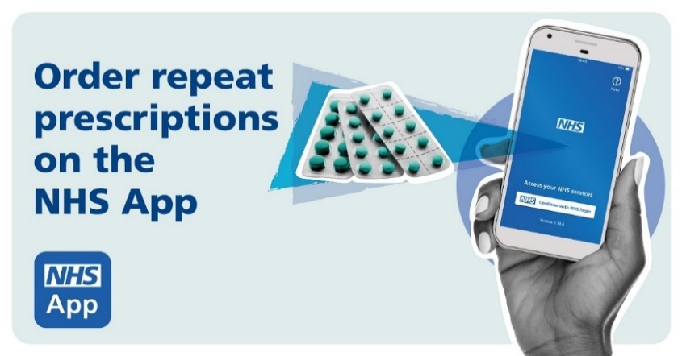

**Did You Know?**

90% of liver disease is preventable so taking steps

towards a healthier lifestyle can decrease your risk of

liver damage. The liver has the incredible ability to

regenerate, but it’s important to prevent damage before

it becomes irreversible. The three major preventable

causes are drinking alcohol, obesity and viral hepatitis.

Visit the British Liver Trust website to find out more,

get advice if you’re worried about your liver health and

join the pledge to love your liver!

<https://britishlivertrust.org.uk/>

<https://britishlivertrust.org.uk/love-your-liver-month/>

Do more with the NHS App. The NHS App is simple to use and will give you access to a range of NHS service. This can easily be download onto your smartphone or tablet, allowing you to make the most of the services we provide.

With full access you can:

* **Order and manage your repeat prescriptions.**
* View your GP health record.
* Use NHS 111 online for things like instant advice or to find medical help near you.
* Plus, lots more…

For more information visit the NHS website where you can find help and support: <https://www.nhs.uk/nhs-app/nhs-app-help-and-support/>

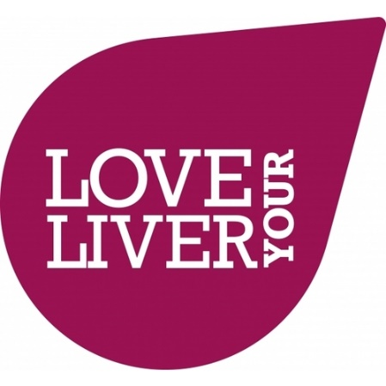

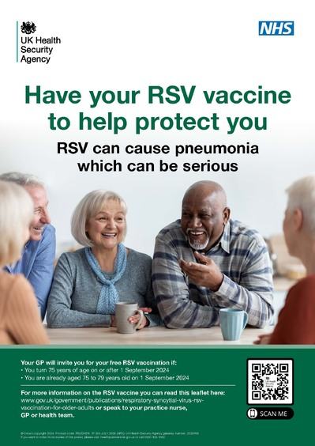

**RSV Vaccination:**

The RSV vaccine helps protect against [respiratory syncytial virus (RSV)](https://www.nhs.uk/conditions/respiratory-syncytial-virus-rsv/). The RSV vaccine is recommended and offered to those who are:

* pregnant (from 28 weeks onwards) to help protect your baby after they are born.
* aged 75 to 79.

RSV is a common cause of coughs and colds, and most people get it several times during their life. It usually gets better by itself, but in some people (especially babies and older adults) it can cause other problems like pneumonia and bronchiolitis.

Everyone turning 75 years old on or after the 1 September 2024 will be offered a single dose of RSV vaccine.

If you are pregnantspeak to your maternity service or GP surgery if you are 28 weeks or more and have not been offered the vaccine.

**The NHS App**

Do more with the NHS App. The NHS App is simple to use and will give you access to a range of NHS service. This can easily be download onto your smartphone or tablet, allowing you to make the most of the services we provide.

With full access you can:

* **Order and track your repeat prescriptions.**
* View your GP health record, including detailed test results.
* View upcoming and past appointments.
* Manage health services for others.
* Use NHS 111 online for things like instant advice or to find medical help near you.
* Plus, lots more…

For more information visit the NHS website where you can find help and support: <https://www.nhs.uk/nhs-app/nhs-app-help-and-support/>

We are also happy to help at the practice, just ask for our NHS App Champion.

It is **Love Your Liver Month**

90% of liver disease is preventable so taking steps

towards a healthier lifestyle can decrease your risk of

liver damage. The liver has the incredible ability to

regenerate, but it’s important to prevent damage before

it becomes irreversible. The three major preventable

causes are drinking alcohol, obesity and viral hepatitis.

Visit the British Liver Trust website to find out more,

get advice if you’re worried about your liver health and

join the pledge to love your liver!



**Have your say by joining the PPG!**

The Patient Participation Group (or PPG) is a group of people who volunteer and are patients at our surgery. The PPG is designed to ensure patients at our surgery, their families and carers are represented and supported at every stage of their care. In joining the PPG, you can help other patients by working with the practice staff to voice the collective concerns of patients in the community and resolve outstanding problems with your feedback.

Your experiences matter and you can bring different ideas to the practice which will help us to treat patients better and deliver the best service we can through cooperative improvement. Both the practice and the PPG want to ensure we can work as best as it can for patients, doctors and staff.

If you would be interested in joining the Patient Participation Group at Burton Latimer Medical Centre, please find further information on our website about how to get involved or call us to let us know. We are eager to start implementing the improvements you are looking for!

Visit the patient’s association website for more information regarding Patient Participation Groups: <https://www.patients-association.org.uk/pages/category/patient-participation-groups>

**About US: Our Nurse Practitioners**

The team consists of 4 members, who are highly skilled senior nurses with further qualifications and advanced clinical skills.

They are able to:

* take a full medical history
* carry out physical assessments and examinations
* make a diagnosis and enable relevant treatment
* prescribe medicines
* plan for follow up treatment
* refer patients for investigations

Patients with an acute (short term) illness may see a Nurse Practitioner rather than a GP, but they are also able to treat more conditions.

The nurse practitioner will have access to the on-call GP for advice and support if clinically required.

They also have their own areas of special interest.



**Finally, we are excited to let you know that our new BLMC website will be coming very soon!**

**Follow us on Facebook and Instagram @burtonlatimermedicalcentre**

**Cancelling Appointments: Please make sure you inform the practice as soon as possible if you need to cancel your appointment. You can do this on the phone by calling 01536 723566, through our website or on the NHS App.** Missed appointments are a waste of our health professionals time, and these unused slots could be used in order to see another patient.